**Build APIs with Node.js and Express.js for Shoppyglobe E-commerce**

**Index**

1. **GET /api/products: Fetch a list of products from MongoDB.**
2. **GET /api/products/:id: Fetch details of a single product by its ID.**
3. **POST /api/cart/add: Add a product to the shopping cart.**
4. **PUT /api/cart/update/dec: Update the quantity of a product in the cart.**

PUT /api/cart/update/dec: Update the quantity (handleMinus '-') of a product in the cart.

1. **PUT /api/cart/update/inc: Update the quantity of a product in the cart.**

PUT /cart: Update the quantity (handlePlus '+') of a product in the cart.

1. **DELETE /api/cart/remove/:id: Remove a product from the cart.**
2. **POST /register: Register a new user.**
3. **POST /login: Authenticate user and return a JWT token.**

GitHub repository link:

<https://github.com/Vaibhav-Dewangan/ShoppyGlobe-APIs.git>

**GET /api/products: Fetch a list of products from MongoDB.**

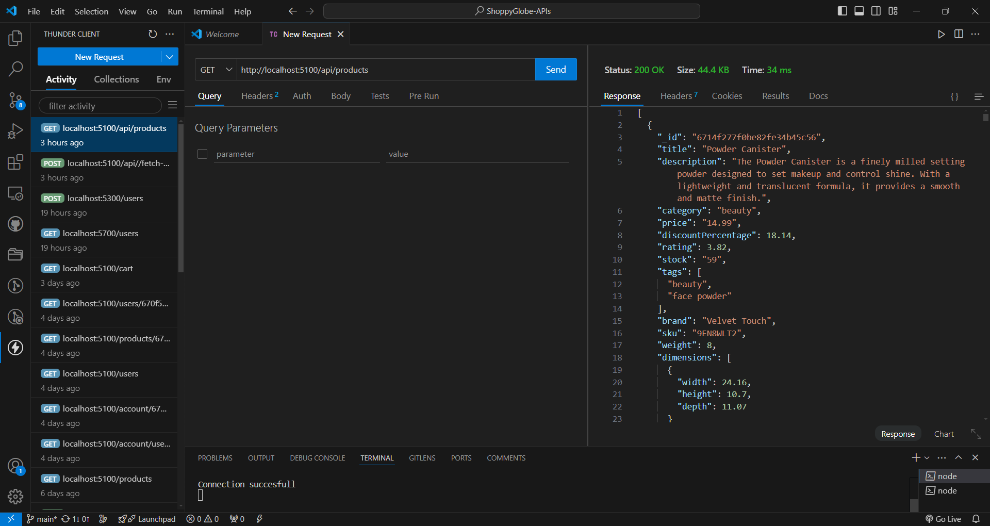

**GET /api/products/:id: Fetch details of a single product by its ID.**

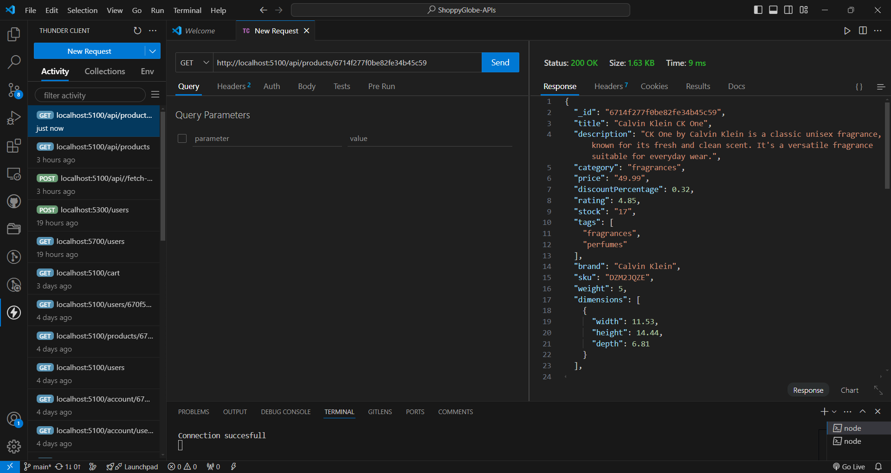

**POST /api/cart/add: Add a product to the shopping cart.**

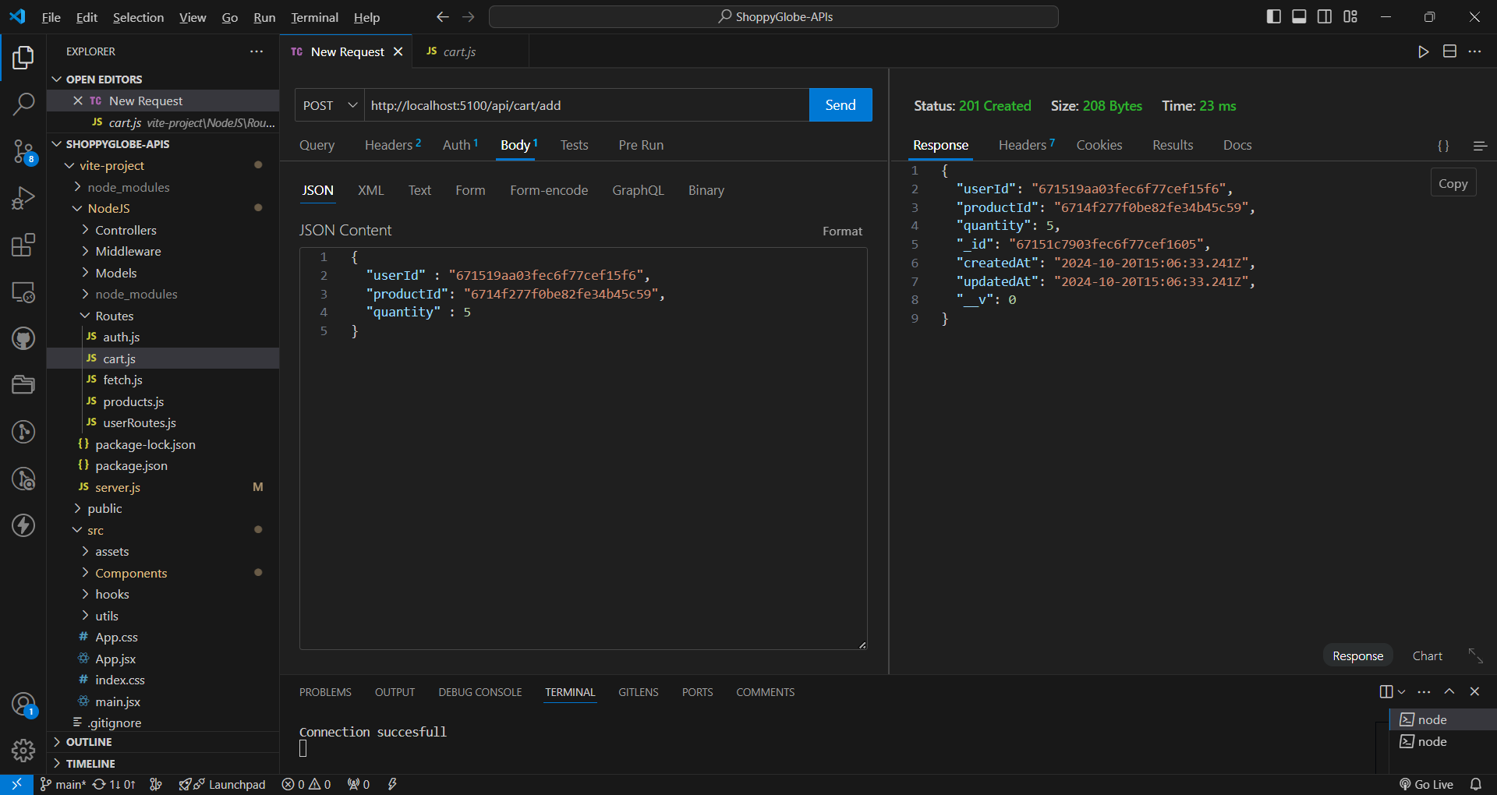

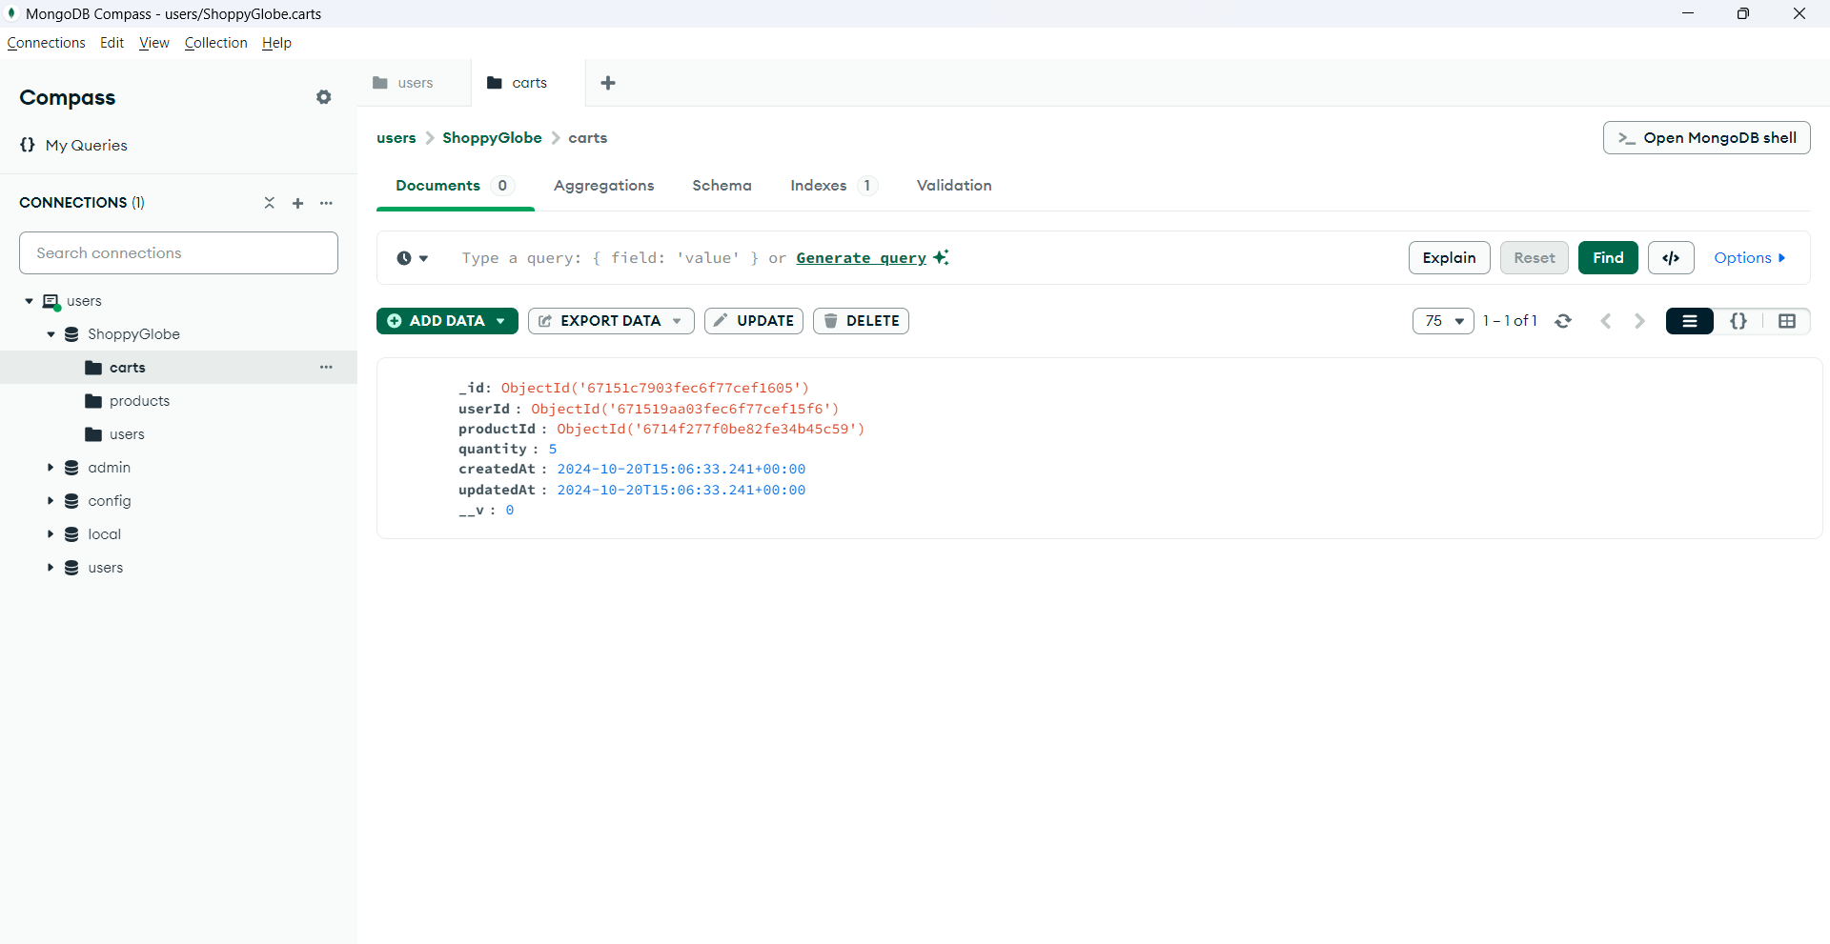

**PUT /api/cart/update/dec: Update the quantity of a product in the cart.**

* PUT /api/cart/update/dec: Update the quantity (handleMinus '-') of a product in the cart.

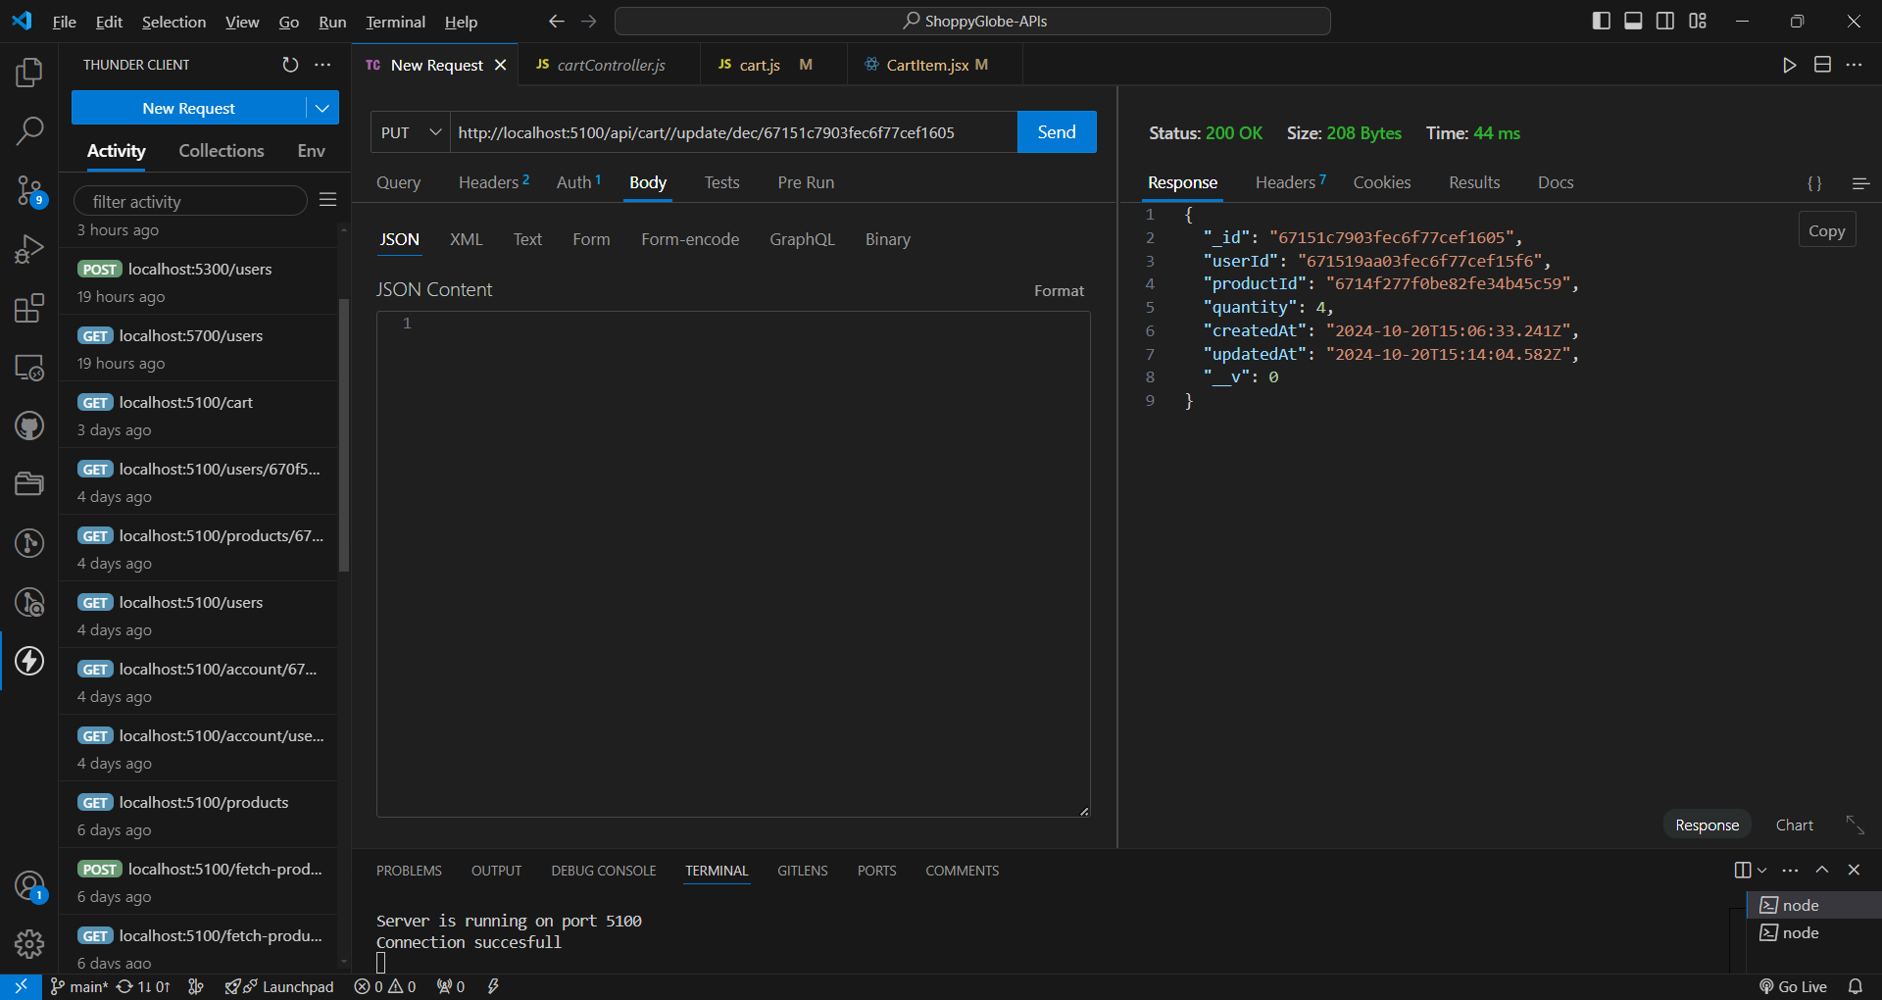

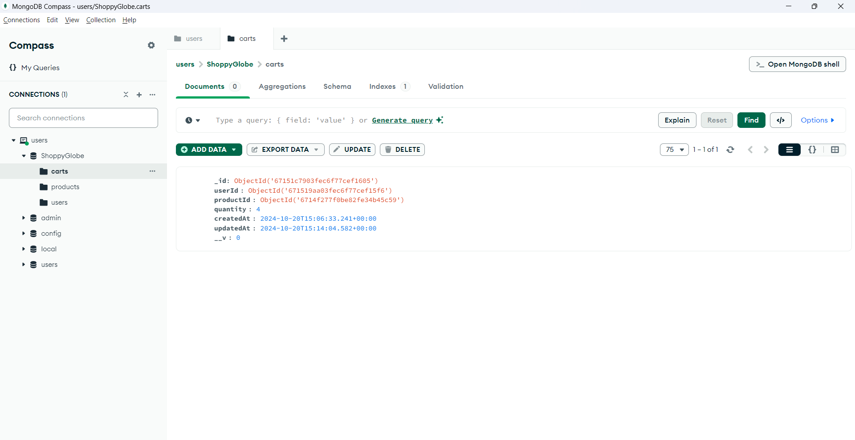

**PUT /api/cart/update/inc: Update the quantity of a product in the cart.**

* PUT /cart: Update the quantity (handlePlus '+') of a product in the cart.

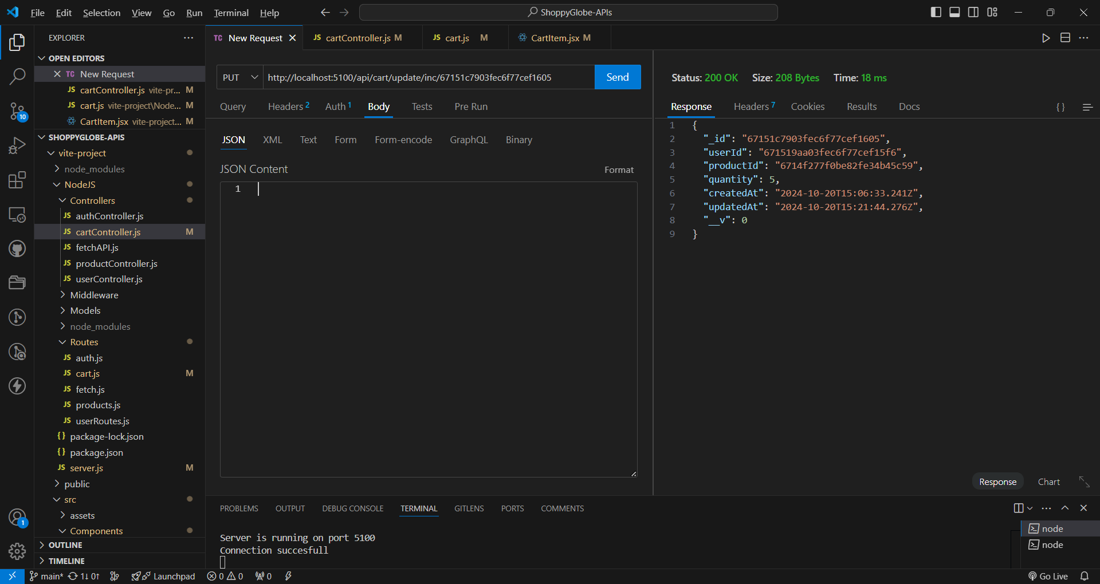

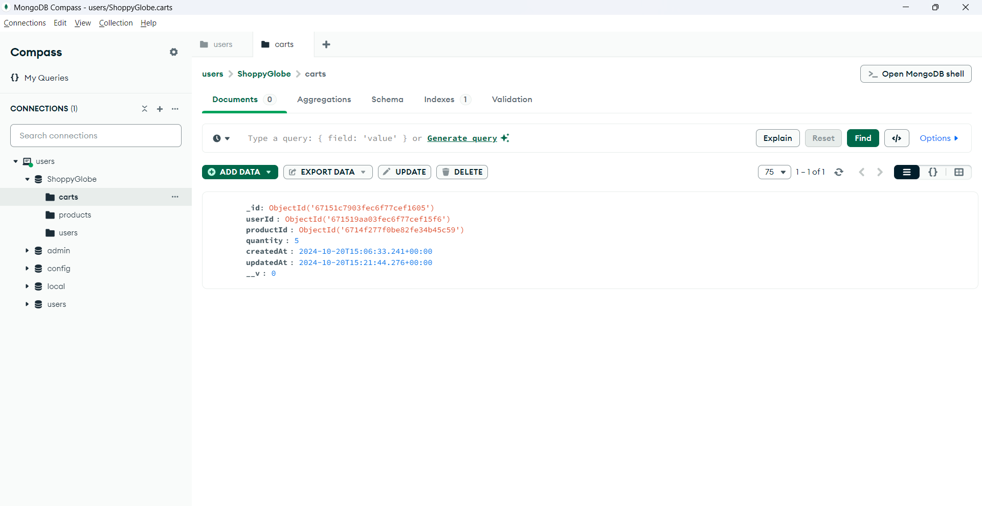

**DELETE /api/cart/remove/:id : Remove a product from the cart.**

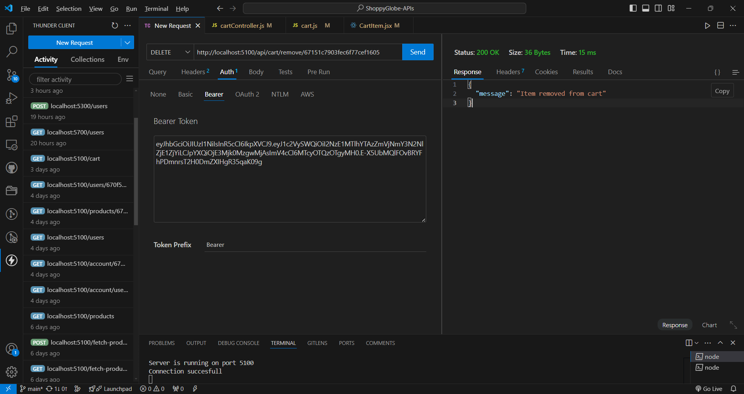

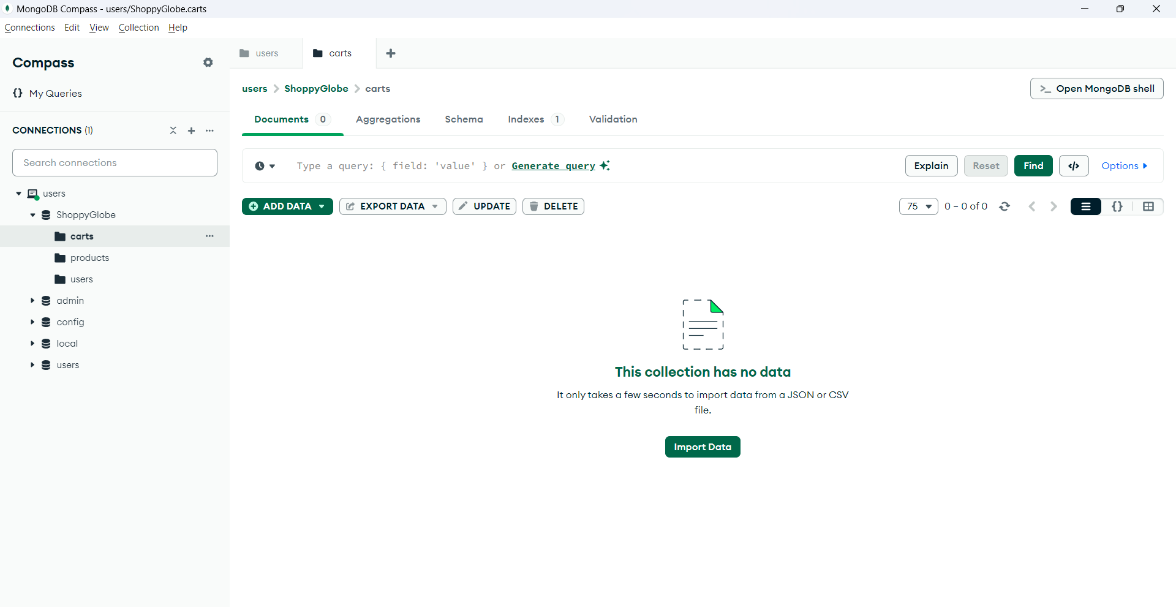

**DELETE /api/cart/clear : Clear Cart**

before

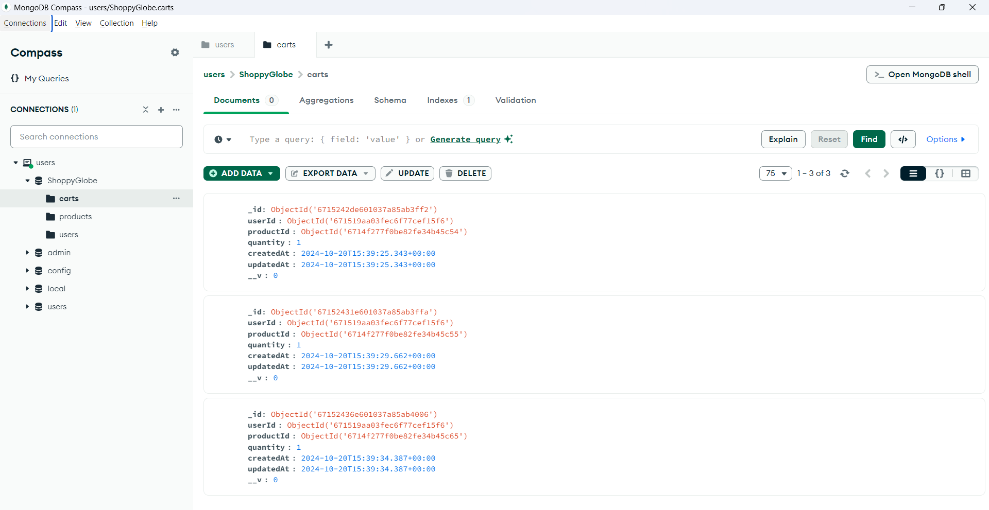

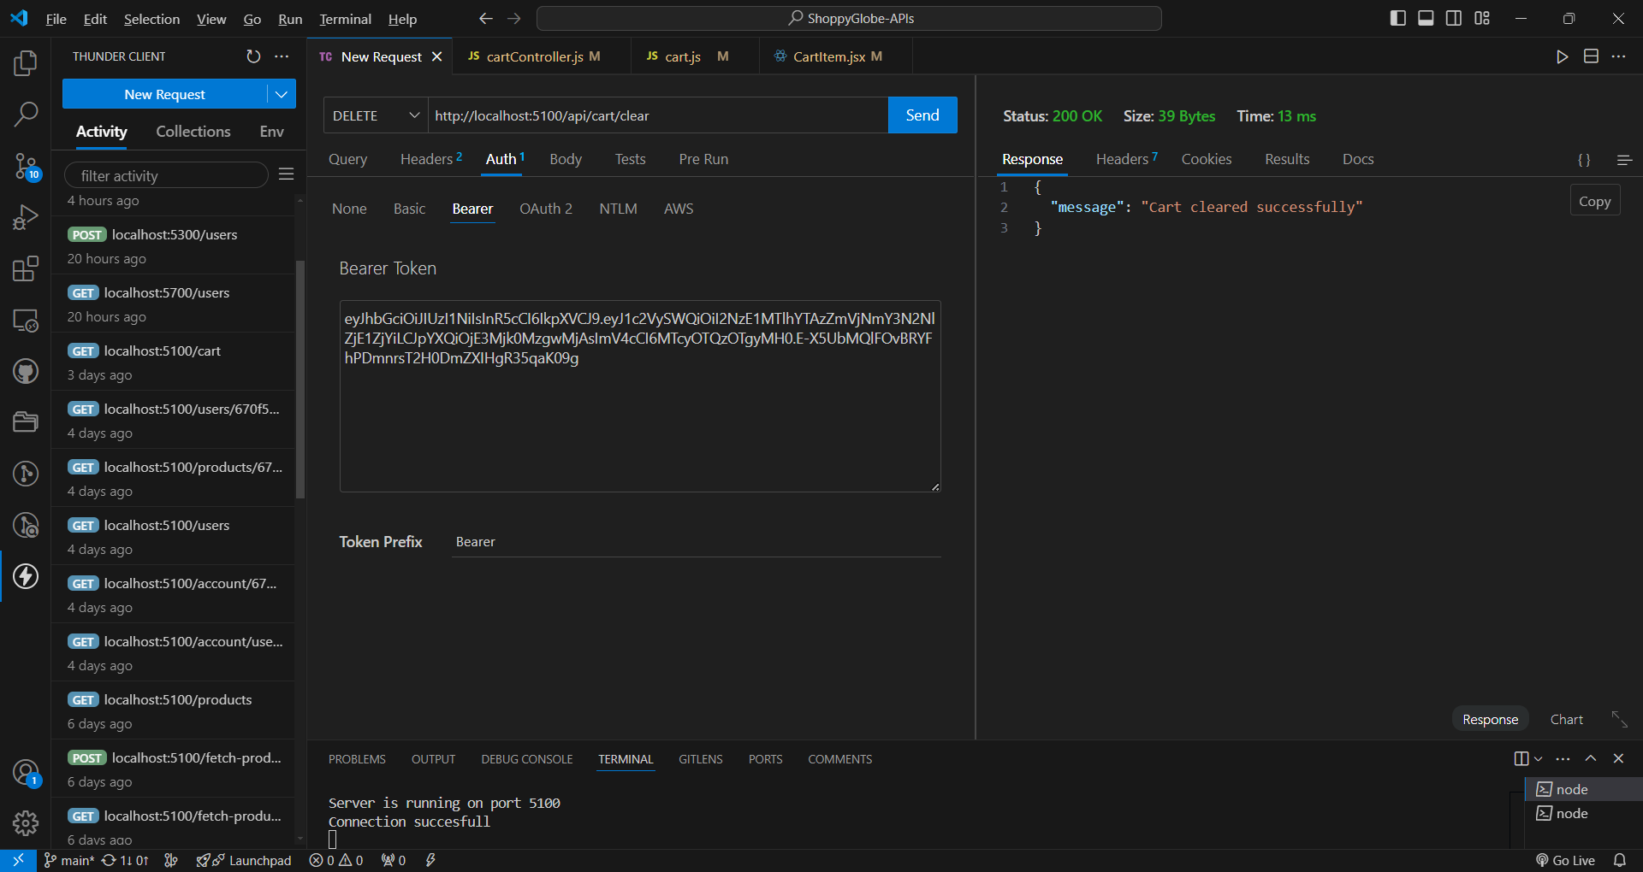

After

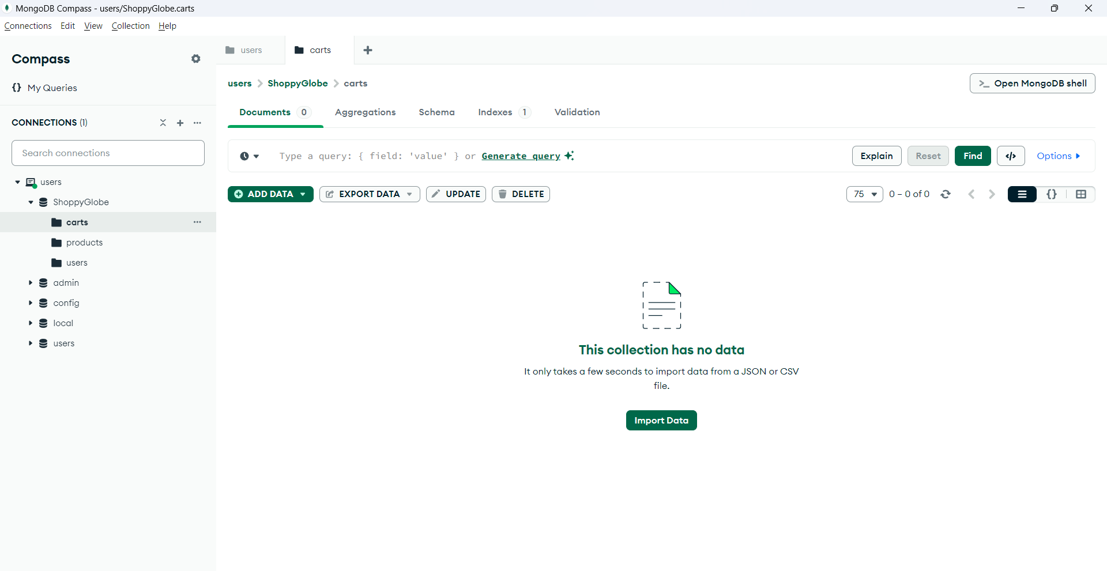

**POST /register: Register a new user.**

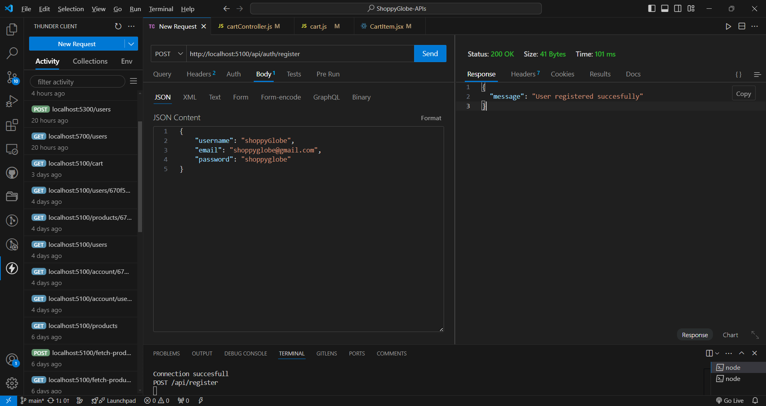

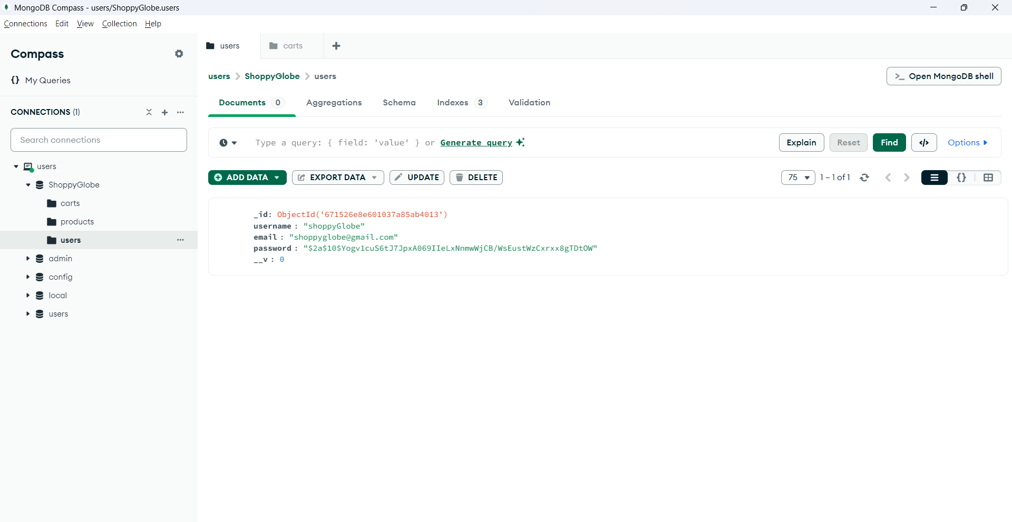

**POST /login: Authenticate user and return a JWT token.**

